Corporate Finance, 4e (Berk / DeMarzo)
Chapter 17 Payout Policy

17.1 Distributions to Shareholders

1) The date on which the board authorizes the dividend is the:
A) declaration date.
B) distribution date.
C) record date.
D) ex-dividend date.
Answer: A
Diff: 1
Section: 17.1 Distributions to Shareholders
Skill: Definition

2) The firm will pay the dividend to all shareholders who are registered owners on a specific date, set by the board, called the:
A) declaration date.
B) record date.
C) distribution date.
D) ex-dividend date.
Answer: B
Diff: 1
Section: 17.1 Distributions to Shareholders
Skill: Definition

3) Anyone who purchases the stock on or after the ________ date will not receive the dividend.
A) distribution
B) record
C) ex-dividend
D) declaration
Answer: C
Diff: 1
Section: 17.1 Distributions to Shareholders
Skill: Definition

4) The firm mails dividend checks to the registered shareholders on the:
A) ex-dividend date.
B) declaration date.
C) distribution date.
D) record date.
Answer: C
Diff: 1
Section: 17.1 Distributions to Shareholders
Skill: Definition
5) Which of the following statements is FALSE?
A) From an accounting perspective, dividends generally reduce the firm's current (or accumulated) retained earnings.
B) The way a firm chooses between paying dividends and retaining earnings is referred to as its payout policy.
C) Most companies that pay dividends pay them semiannually.
D) Occasionally, a firm may pay a one-time, special dividend that is usually much larger than a regular dividend.
Answer: C
Diff: 2
Section: 17.1 Distributions to Shareholders
Skill: Conceptual

6) A firm can repurchase shares through a(n) ________ in which it offers to buy shares at a prespecified price during a short time period—generally within 20 days.
A) tender offer
B) open market share repurchases
C) targeted repurchase
D) Dutch auction share repurchase
Answer: A
Diff: 2
Section: 17.1 Distributions to Shareholders
Skill: Definition

7) A method to repurchase shares is the ________, in which the firm lists different prices at which it is prepared to buy shares, and shareholders in turn indicate how many shares they are willing to sell at each price.
A) tender offer
B) Dutch auction share repurchase
C) targeted repurchase
D) open market share repurchases
Answer: B
Diff: 2
Section: 17.1 Distributions to Shareholders
Skill: Definition

8) A(n) ________ may occur if a major shareholder desires to sell a large number of shares but the market for the shares is not sufficiently liquid to sustain such a large sale without severely affecting the price.
A) open market share repurchases
B) Dutch auction share repurchase
C) tender offer
D) targeted repurchase
Answer: D
Diff: 2
Section: 17.1 Distributions to Shareholders
Skill: Definition
9) A(n) ________ is the most common way that firms repurchase shares.
A) targeted repurchase
B) Dutch auction share repurchase
C) tender offer
D) open market share repurchases
Answer: D
Diff: 2
Section: 17.1 Distributions to Shareholders
Skill: Definition

17.2 Comparison of Dividends and Share Repurchases

1) Taggart Transcontinental has announced a $2 dividend. If Taggart's last price cum-dividend is $45, then, assuming perfect capital markets, what should its first ex-dividend price be?
A) $0
B) $2
C) $43
D) $45
Answer: C
Explanation: C) Pex dividend = Pcum dividend - dividend = $45 - $2 = $43
Diff: 1
Section: 17.2 Comparison of Dividends and Share Repurchases
Skill: Analytical

Use the following information to answer the question(s) below.

Wyatt Oil has assets with a market value of $600 million, $70 million of which are cash. It has debt of $250 million, and 20 million shares outstanding. Assume perfect capital markets.

2) Wyatt Oil's current stock price is closest to:
A) $11.00
B) $12.50
C) $14.00
D) $17.50
Answer: D
Explanation: D) price = 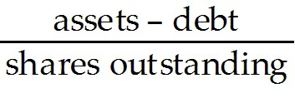 = 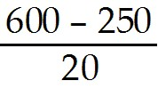 = $17.50
Diff: 1
Section: 17.2 Comparison of Dividends and Share Repurchases
Skill: Analytical
3) If Wyatt Oil distributes the $70 million as a dividend, then its stock price after the dividend will be closest to:
A) $12.50
B) $14.00
C) $17.50
D) $26.50
Answer: B
Explanation: B) price = 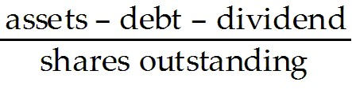 = 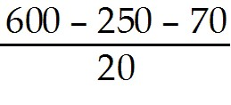 = $14.00
Diff: 2
Section: 17.2 Comparison of Dividends and Share Repurchases
Skill: Analytical

4) If Wyatt Oil distributes the $70 million as a share repurchase, then its stock price after the share repurchase will be closest to:
A) $11.00
B) $12.50
C) $14.00
D) $17.50
Answer: D
Explanation: D) current price = = = $17.50
Therefore Wyatt Oil will repurchase $70 million/$17.50 = 4 million shares, leaving 20 - 4 = 16 million shares outstanding.
Therefore after the repurchase price = = 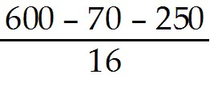 = $17.50
Diff: 2
Section: 17.2 Comparison of Dividends and Share Repurchases
Skill: Analytical

5) If Wyatt Oil distributes the $70 million as a share repurchase, then the number of shares outstanding after the repurchase will be closest to:
A) 16.0 million
B) 16.5 million
C) 17.5 million
D) 18.0 million
Answer: A
Explanation: A) current price = = = $17.50
Therefore Wyatt Oil will repurchase $70 million/$17.50 = 4 million shares, leaving 20 - 4 = 16 million shares outstanding
Diff: 2
Section: 17.2 Comparison of Dividends and Share Repurchases
Skill: Analytical
6) If Wyatt Oil distributes the $70 million as a dividend, then its debt-to-equity ratio after the dividend will be closest to:
A) 0.7
B) 0.9
C) 1.0
D) 1.1
Answer: B
Explanation: B) equity = assets - debt, after the distribution, assets = 600 -70 = 530, so equity = 530 - 250 = $280 million, so the debt to equity ratio = $250/$280 = 0.892857
Diff: 1
Section: 17.2 Comparison of Dividends and Share Repurchases
Skill: Analytical

7) If Wyatt Oil distributes the $70 million as a share repurchase, then its debt-to-equity ratio after the share repurchase will be closest to:
A) 0.9
B) 1.0
C) 1.1
D) 1.4
Answer: A
Explanation: A) equity = assets - debt, after the distribution, assets = 600 - 70 = 530, so equity = 530 - 250 = $280 million, so the debt to equity ratio = $250/$280 = 0.892857
Diff: 2
Section: 17.2 Comparison of Dividends and Share Repurchases
Skill: Analytical

8) Which of the following statements is FALSE?
A) In perfect capital markets, holding fixed the investment policy of a firm, the firm's choice of dividend policy is irrelevant and does not affect the initial share price.
B) In a perfect capital market, when a dividend is paid, the share price drops by the amount of the dividend when the stock begins to trade ex-dividend.
C) In perfect capital markets, an open market share repurchase has no effect on the stock price, and the stock price is the same as the ex-dividend price if a dividend were paid instead.
D) In perfect capital markets, investors are indifferent between the firm distributing funds via dividends or share repurchases. By reinvesting dividends or selling shares, they can replicate either payout method on their own.
Answer: C
Diff: 1
Section: 17.2 Comparison of Dividends and Share Repurchases
Skill: Conceptual
Use the information for the question(s) below.

Omicron Technologies has $50 million in excess cash and no debt. The firm expects to generate additional free cash flows of $40 million per year in subsequent years and will pay out these future free cash flows as regular dividends. Omicrons unlevered cost of capital is 10% and there are 10 million shares outstanding. Omicron's board is meeting to decide whether to pay out its $50 million in excess cash as a special dividend or to use it to repurchase shares of the firm's stock.

9) Omicron's enterprise value is closest to:
A) $500 million
B) $900 million
C) $450 million
D) $400 million
Answer: D
Explanation: D) Enterprise Value = PV(Future FCF) = 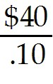 = $400 million
Diff: 1
Section: 17.2 Comparison of Dividends and Share Repurchases
Skill: Analytical

10) Including its cash, Omicron's total market value is closest to:
A) $500 million
B) $900 million
C) $400 million
D) $450 million
Answer: D
Explanation: D) Enterprise Value - PV(Future FCF) = = $400 million
Market value = Enterprise Value + cash = $400 + $50 = $450 million
Diff: 1
Section: 17.2 Comparison of Dividends and Share Repurchases
Skill: Analytical

11) Assume that Omicron uses the entire $50 million in excess cash to pay a special dividend. The amount of the special dividend is closest to:
A) $5.00
B) $9.00
C) $4.00
D) $4.50
Answer: A
Explanation: A) Dividend = 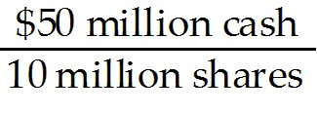 = $5 per share
Diff: 1
Section: 17.2 Comparison of Dividends and Share Repurchases
Skill: Analytical
12) Assume that Omicron uses the entire $50 million in excess cash to pay a special dividend. The amount of the regular yearly dividends in the future is closest to:
A) $4.50
B) $5.00
C) $4.00
D) $9.00
Answer: C
Explanation: C) Dividend = 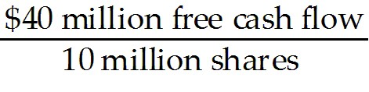 = $4 per share
Diff: 1
Section: 17.2 Comparison of Dividends and Share Repurchases
Skill: Analytical

13) Assume that Omicron uses the entire $50 million in excess cash to pay a special dividend. Omicron's cum-dividend price is closest to:
A) $50.00
B) $40.00
C) $5.00
D) $45.00
Answer: D
Explanation: D) Enterprise Value - PV(Future FCF) = = $400 million
Market value = Enterprise Value + cash = $400 + $50 = $450 million

Share price = 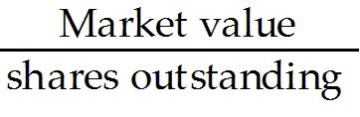 = 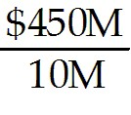 = $45.00
Diff: 2
Section: 17.2 Comparison of Dividends and Share Repurchases
Skill: Analytical

14) Assume that Omicron uses the entire $50 million in excess cash to pay a special dividend. Omicron's ex-dividend price is closest to:
A) $40.00
B) $5.00
C) $50.00
D) $45.00
Answer: A
Explanation: A) Enterprise Value - PV(Future FCF) = = $400 million
Market value = Enterprise Value + cash = $400 + $50 = $450 million

However, once the $50 million in cash is used to pay the dividend, the new market value becomes $450 - $50 = $400 Million

Share price = = 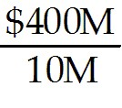 = $40.00
Diff: 2
Section: 17.2 Comparison of Dividends and Share Repurchases
Skill: Analytical
15) Assume that Omicron uses the entire $50 million to repurchase shares. The number of shares that Omicron will repurchase is closest to:
A) 1.0 million
B) 1.2 million
C) 1.1 million
D) 0.9 million
Answer: C
Explanation: C) Enterprise Value - PV(Future FCF) = = $400 million
Market value = Enterprise Value + cash = $400 + $50 = $450 million

Share price = = = $45.00

Number of shares repurchased = 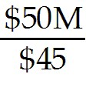 = 1,111,111 shares
Diff: 2
Section: 17.2 Comparison of Dividends and Share Repurchases
Skill: Analytical

16) Assume that Omicron uses the entire $50 million to repurchase shares. The number of shares that Omicron will have outstanding following the repurchase is closest to:
A) 8.8 million
B) 1.2 million
C) 9.0 million
D) 8.9 million
Answer: D
Explanation: D) Enterprise Value - PV(Future FCF) = = $400 million
Market value = Enterprise Value + cash = $400 + $50 = $450 million

Share price = = = $45.00

Number of shares repurchased = = 1,111,111 shares

Shares outstanding = 10 million - 1,111,111 = 8,888,889 shares
Diff: 2
Section: 17.2 Comparison of Dividends and Share Repurchases
Skill: Analytical
17) Assume that Omicron uses the entire $50 million to repurchase shares. The amount of the regular yearly dividends in the future is closest to:
A) $9.00
B) $5.00
C) $4.50
D) $4.00
Answer: C
Explanation: C) Enterprise Value - PV(Future FCF) = = $400 million
Market value = Enterprise Value + cash = $400 + $50 = $450 million

Share price = = = $45.00

Number of shares repurchased = = 1,111,111 shares

Shares outstanding = 10 million - 1,111,111 = 8,888,889 shares

Dividend = 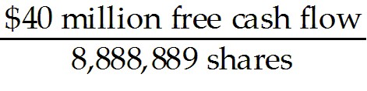 = $4.50 per share
Diff: 3
Section: 17.2 Comparison of Dividends and Share Repurchases
Skill: Analytical

18) Assume that you own 2500 shares of Omicron stock and that Omicron uses the entire $50 million to repurchase shares. Suppose you are unhappy with Omicron's decision and would prefer that Omicron used the excess cash to pay a special dividend. The number of shares that you would have to sell in order to receive the same amount of cash as if Omicron paid the special dividend is closest to:
A) 275
B) 310
C) 125
D) 250
Answer: A
Explanation: A) Enterprise Value - PV(Future FCF) = = $400 million
Market value = Enterprise Value + cash = $400 + $50 = $450 million

Share price = = = $45.00

Dividends that you wanted to receive = 2500 shares × $5 share = $12,500

Number of shares to sell = 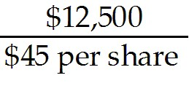 = 277.78 shares
Diff: 3
Section: 17.2 Comparison of Dividends and Share Repurchases
Skill: Analytical
19) Assume that you own 2500 shares of Omicron stock and that Omicron uses the entire $50 million to pay a special dividend. Suppose you are unhappy with Omicron's decision and would prefer that Omicron used the excess cash to repurchase shares. The number of shares that you would have to buy in order to undo the special cash dividend that Omicron paid is closest to:
A) 125
B) 275
C) 250
D) 310
Answer: D
Explanation: D) Enterprise Value - PV(Future FCF) = = $400 million
Market value = Enterprise Value + cash = $400 + $50 = $450 million

However, once the $50 million in cash is used to pay the dividend, the new market value becomes $450 - $50 = $400 Million

Share price = = = $40.00

Dividends that you did not want to receive = 2500 shares × $5 share = $12,500

Number of shares to sell = 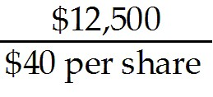 = 312.50 shares
Diff: 3
Section: 17.2 Comparison of Dividends and Share Repurchases
Skill: Analytical

20) Assume that you own 4000 shares of Omicron stock and that Omicron uses the entire $50 million to repurchase shares. Suppose you are unhappy with Omicron's decision and would have preferred that Omicron used the excess cash to pay a special dividend. Detail exactly how you could create a homemade dividend that will provide you with the same combination of cash and stock that you would have received if Omicron paid the special dividend.
Answer: What you have:

Enterprise Value = PV(Future FCF) = = $400 million
Market value = Enterprise Value + cash = $400 + $50 = $450 million

Share price = = = $45.00 × 4000 shares = $180,000 of stock.

What you want:

Enterprise Value - PV(Future FCF) = = $400 million
Market value = Enterprise Value + cash = $400 + $50 = $450 million

However, once the $50 million in cash is used to pay the dividend, the new market value becomes $450 - $50 = $400 Million

Share price = = = $40.00 × 4000 shares = $160,000 of stock

Dividends that you want to receive = 4000 shares × $5 share = $20,000 cash

What you need to do:

You have $180,000 in stock and want $160,000 in stock and $20,000 in cash, so you must sell $20,000 worth of stock. To accomplish this:

Number of shares to sell = 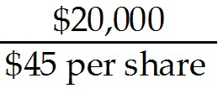 = 444.44 shares

So by selling 444.44 shares you obtain the desired results.
Diff: 3
Section: 17.2 Comparison of Dividends and Share Repurchases
Skill: Analytical

21) Assume that you own 4000 shares of Omicron stock and that Omicron uses the entire $50 million to pay a special dividend. Suppose you are unhappy with Omicron's decision and would have preferred that Omicron used the excess cash to repurchase stock. Detail exactly how you could undo the dividend in a way that will provide you with the same combination of cash and stock that you would have received if Omicron had not paid the special dividend.
Answer: What you want:

Enterprise Value = PV(Future FCF) = = $400 million
Market value = Enterprise Value + cash = $400 + $50 = $450 million

Share price = = = $45.00 × 4000 shares = $180,000 of stock.

What you have:

Enterprise Value = PV(Future FCF) = = $400 million
Market value = Enterprise Value + cash = $400 + $50 = $450 million

However, once the $50 million in cash is used to pay the dividend, the new market value becomes $450 - $50 = $400 Million

Share price = = = $40.00 × 4000 shares = $160,000 of stock

Dividends that you did not want to receive = 4000 shares × $5 share = $20,000 cash

What you need to do:

You have $160,000 in stock and $20,000 in cash and you want $180,000 in stock, so you must buy $20,000 worth of stock. To accomplish this:

Number of shares to buy = 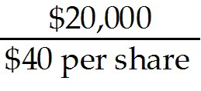 = 500 shares

So by buying 500 shares you obtain the desired results.
Diff: 3
Section: 17.2 Comparison of Dividends and Share Repurchases
Skill: Analytical

17.3 The Tax Disadvantage of Dividends

Use the following information to answer the question(s) below.

Year(s) | Capital Gains | Dividends
1987 | 28% | 39%
1988 - 1990 | 28% | 28%
1991 - 1992 | 28% | 31%
1993 - 1996 | 28% | 40%
1997 - 2000 | 20% | 40%
2001 - 2002 | 20% | 39%
2003 - 2009 | 15% | 15%

1) In which years were dividends tax disadvantaged?
A) 1987 - 2002
B) 1987, 1993 - 2002
C) 1987, 1991 - 2002
D) 1988 - 1990, 2003 - 2009
Answer: C
Explanation: C) Dividends are tax disadvantaged in any year where the tax rate on dividends is greater than the capital gains rate.

Year(s) | Capital Gains | Dividends | Disadvantaged
1987 | 28% | 39% | Yes
1988 - 1990 | 28% | 28% | No
1991 - 1992 | 28% | 31% | Yes
1993 - 1996 | 28% | 40% | Yes
1997 - 2000 | 20% | 40% | Yes
2001 - 2002 | 20% | 39% | Yes
2003 - 2009 | 15% | 15% | No
Diff: 1
Section: 17.3 The Tax Disadvantage of Dividends
Skill: Analytical
2) In which years were dividends NOT tax disadvantaged?
A) 1987 - 2002
B) 1987, 1993 - 2002
C) 1987, 1991 - 2002
D) 1988 - 1990, 2003 - 2009
Answer: D
Explanation: D) Dividends are tax disadvantaged in any year where the tax rate on dividends is greater than the capital gains rate. Dividends are not tax disadvantaged in any year where the dividend rate is the same as the capital gains rate.

Year(s) | Capital Gains | Dividends | Disadvantaged
1987 | 28% | 39% | Yes
1988 - 1990 | 28% | 28% | No
1991 - 1992 | 28% | 31% | Yes
1993 - 1996 | 28% | 40% | Yes
1997 - 2000 | 20% | 40% | Yes
2001 - 2002 | 20% | 39% | Yes
2003 - 2009 | 15% | 15% | No
Diff: 1
Section: 17.3 The Tax Disadvantage of Dividends
Skill: Analytical

3) Which of the following statements is FALSE?
A) Unlike with capital structure, taxes are not an important market imperfection that influence a firm's decision to pay dividends or repurchase shares.
B) If dividends are taxed at a higher rate than capital gains, which has been true until the most recent change to the tax code, shareholders will prefer share repurchases to dividends.
C) Shareholders typically must pay taxes on the dividends they receive. They must also pay capital gains taxes when they sell their shares.
D) Because long-term investors can defer the capital gains tax until they sell, there is still a tax advantage for share repurchases over dividends.
Answer: A
Diff: 1
Section: 17.3 The Tax Disadvantage of Dividends
Skill: Conceptual
4) Which of the following statements is FALSE?
A) When a firm pays a dividend, shareholders are taxed according to the dividend tax rate. If the firm repurchases shares instead, and shareholders sell shares to create a homemade dividend, the homemade dividend will be taxed according to the capital gains tax rate.
B) When the tax rate on dividends exceeds the tax rate on capital gains, shareholders will pay lower taxes if a firm uses share repurchases for all payouts rather than dividends.
C) Firms that use dividends will have to pay a lower after-tax return to offer their investors the same pre-tax return as firms that use share repurchases.
D) The optimal dividend policy when the dividend tax rate exceeds the capital gain tax rate is to pay no dividends at all.
Answer: C
Diff: 2
Section: 17.3 The Tax Disadvantage of Dividends
Skill: Conceptual

5) Which of the following statements is FALSE?
A) While firms do still pay dividends, substantial evidence shows that many firms have recognized their tax disadvantage.
B) The fact that firms continue to issue dividends despite their tax disadvantage is often referred to as the dividend puzzle.
C) At the end of the 1990s, dividend payments exceeded the value of repurchases for U.S. industrial firms.
D) While evidence is indicative of the growing importance of share repurchases as a part of firms' payout policies, it also shows that dividends remain a key form of payouts to shareholders.
Answer: C
Diff: 2
Section: 17.3 The Tax Disadvantage of Dividends
Skill: Conceptual

Use the information for the question(s) below.

The JRN Corporation will pay a constant dividend of $3 per share, per year, in perpetuity. Assume that all investors pay a 20% tax on dividends and that there is no capital gains tax. The cost of capital for investing in JRN stock is 12%.

6) The price of a share of JRN's stock is closest to:
A) $20.00
B) $24.00
C) $25.00
D) $18.00
Answer: A
Explanation: A) Price = 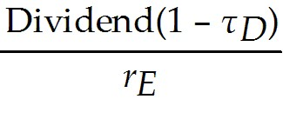 = 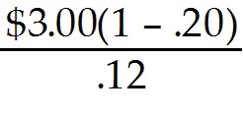 = $20.00
Diff: 1
Section: 17.3 The Tax Disadvantage of Dividends
Skill: Analytical
7) Assume that management makes a surprise announcement that JRN will no longer pay dividends but will use the cash to repurchase stock instead. The price of a share of JRN's stock is now closest to:
A) $20.00
B) $25.00
C) $18.00
D) $24.00
Answer: B
Explanation: B) In a perfect capital market the dividend/repurchase decision does not impact firm value. Since the tax rate for repurchases is zero, the stock price would be the same as if the firm paid out the dividend and the dividends were not taxed, so:

Price = 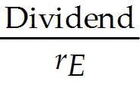 = 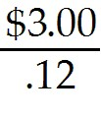 = $25.00
Diff: 2
Section: 17.3 The Tax Disadvantage of Dividends
Skill: Analytical

17.4 Dividend Capture and Tax Clienteles

Use the following information to answer the question(s) below.

Year(s) | Capital Gains | Dividends
1987 | 28% | 39%
1988 - 1990 | 28% | 28%
1991 - 1992 | 28% | 31%
1993 - 1996 | 28% | 40%
1997 - 2000 | 20% | 40%
2001 - 2002 | 20% | 39%
2003 - 2009 | 15% | 15%

1) The effective dividend tax rate in 1989 is closest to:
A) 0%
B) 20%
C) 25%
D) 30%
Answer: A
Explanation: A) 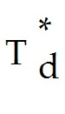 = 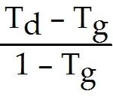 = 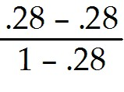 = 0 or 0%
Diff: 2
Section: 17.4 Dividend Capture and Tax Clienteles
Skill: Analytical
2) The effective dividend tax rate in 1999 is closest to:
A) 0%
B) 20%
C) 25%
D) 30%
Answer: C
Explanation: C) = = 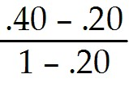 = .25 or 25%
Diff: 2
Section: 17.4 Dividend Capture and Tax Clienteles
Skill: Analytical

3) Wyatt Oil pays a regular dividend of $2.50 per share. Typically the stock price drops by $2.00 per share when the stock goes ex-dividend. Suppose the capital gains tax rate is 20%, but investors pay different tax rates on dividends. Absent transactions cost, the highest dividend tax rate of an investor who could gain from trading to capture the dividend is closest to:
A) 0%
B) 20%
C) 24%
D) 36%
Answer: D
Explanation: D) (Pcum - Pex)(1 - Tg) = DIV(1 - Td) → $2.00 (1 - .20) = $2.50 (1 - Td)
→ 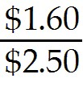 = 1 - Td → Td = 1 - → td = .36 or 36%
At 36% there would be no benefit to capturing the dividend, the tax rate must be slightly below this amount.
Diff: 2
Section: 17.4 Dividend Capture and Tax Clienteles
Skill: Analytical

Use the following information to answer the question(s) below.

Suppose that all capital gains are taxed at a 20% rate, and that the dividend tax rate is 40%. Rearden Metal is currently trading for $40 per share, and is about to pay a $5 special dividend.

4) Absent any other trading frictions or news, Rearden's share price just after the dividend is paid will be closest to:
A) $35
B) $36
C) $37
D) $40
Answer: B
Explanation: B) (Pcum - Pex)(1 - Tg) = DIV(1 - Td)
→ Pex = Pcum - 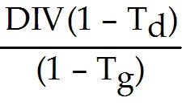 = $40 - 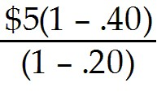 = $36.25
Diff: 2
Section: 17.4 Dividend Capture and Tax Clienteles
Skill: Analytical
5) The effective dividend tax rate for an investor in Rearden Metal is closest to:
A) 0%
B) 20%
C) 25%
D) 30%
Answer: C
Explanation: C) = = = .25 or 25%
Diff: 2
Section: 17.4 Dividend Capture and Tax Clienteles
Skill: Analytical

6) Suppose that Rearden Metal made a surprise announcement that it would do a share repurchase rather than pay a special dividend, the net tax savings per share for an investor that would result from this decision is closest to:
A) $1.25
B) $3.75
C) $4.00
D) $5.00
Answer: A
Explanation: A) The effective dividend tax rate is = = = .25 or 25%, so an investor could save $5.00 × 25% = $1.25 per share if Rearden Metal opts to do a repurchase instead of the dividend.
Diff: 3
Section: 17.4 Dividend Capture and Tax Clienteles
Skill: Analytical

7) Which of the following statements is FALSE?
A) Tax rates vary by income, by jurisdiction, and by whether the stock is held in a retirement account. Because of these differences, firms may attract different groups of investors depending on their dividend policy.
B) While many investors have a tax preference for share repurchases rather than dividends, the strength of that preference depends on the difference between the dividend tax rate and the capital gains tax rate that they face.
C) Long-term investors are more heavily taxed on capital gains, so they would prefer dividend payments to share repurchases.
D) One-year investors, pension funds, and other non-taxed investors have no tax preference for share repurchases over dividends, they would prefer a payout policy that most closely matches their cash needs.
Answer: C
Diff: 2
Section: 17.4 Dividend Capture and Tax Clienteles
Skill: Conceptual
8) Which of the following statements is FALSE?
A) Individuals in the highest tax brackets have a preference for stocks that pay high dividends, whereas tax-free investors and corporations have a preference for stocks with no or low dividends.
B) To compare investor preferences, we must quantify the combined effects of dividend and capital gains taxes to determine an effective dividend tax rate for an investor.
C) The dividend-capture theory states that absent transaction costs, investors can trade shares at the time of the dividend so that non-taxed investors receive the dividend.
D) Differences in tax preferences create clientele effects, in which the dividend policy of a firm is optimized for the tax preference of its investor clientele.
Answer: A
Diff: 2
Section: 17.4 Dividend Capture and Tax Clienteles
Skill: Conceptual

9) Consider the following equation:

Pcum - Pex = Div × 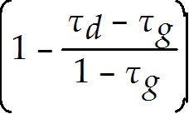

The term Pcum is:
A) the personal tax rate for capital gains.
B) the price per share after a dividend is paid.
C) the price per share before a dividend is paid.
D) the personal tax rate for dividend.
Answer: C
Diff: 1
Section: 17.4 Dividend Capture and Tax Clienteles
Skill: Analytical

10) Consider the following equation:

Pcum - Pex = Div ×

The term τg is:
A) the personal tax rate for dividend.
B) the personal tax rate for capital gains.
C) the price per share before a dividend is paid.
D) the price per share after a dividend is paid.
Answer: B
Diff: 1
Section: 17.4 Dividend Capture and Tax Clienteles
Skill: Analytical
11) Consider the following equation:

Pcum - Pex = Div ×

The term Pex is:
A) the personal tax rate for dividend.
B) the price per share before a dividend is paid.
C) the price per share after a dividend is paid.
D) the personal tax rate for capital gains.
Answer: C
Diff: 1
Section: 17.4 Dividend Capture and Tax Clienteles
Skill: Analytical

12) Consider the following equation:

Pcum - Pex = Div ×

The term τd is:
A) the price per share after a dividend is paid.
B) the price per share before a dividend is paid.
C) the personal tax rate for capital gains.
D) the personal tax rate for dividend.
Answer: D
Diff: 1
Section: 17.4 Dividend Capture and Tax Clienteles
Skill: Analytical

13) Which of the following equations is INCORRECT?
A) Pcum - Pex = Div ×
B) Pcum - Pex = Div × 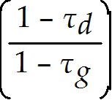
C) 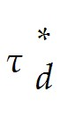 = 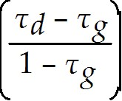
D) (Pcum - Pex)(1 - τd) = Div(1 - τg)
Answer: D
Explanation: D) Correct formula (Pcum - Pex)(1 - τg) = Div(1 - τd)
Diff: 2
Section: 17.4 Dividend Capture and Tax Clienteles
Skill: Analytical
Use the information for the question(s) below.

Consider the following tax rates:

Year | Capital Gains Rate | Ordinary Income Rate | Dividend Rate
1997-2000 | 20% | 40% | 40%
2001-2002 | 20% | 39% | 39%
2003- | 15% | 35% | 15%

*The current tax rates are set to expire in 2008 unless Congress extends them. The tax rates shown are for financial assets held for one year. For assets held less than one year, capital gains are taxed at the ordinary income tax rate (currently 35% for the highest bracket); the same is true for dividends if the assets are held for less than 61 days.

14) The effective dividend tax rate for a buy and hold individual investor in 2006 is closest to:
A) 0%
B) 35%
C) 15%
D) 20%
Answer: C
Explanation: C) τd = 15%, τg = 0% (Buy and Hold)
= = 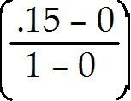 = .15
Diff: 1
Section: 17.4 Dividend Capture and Tax Clienteles
Skill: Analytical

15) The effective dividend tax rate for a one-year individual investor in 2006 is closest to:
A) 20%
B) 15%
C) 35%
D) 0%
Answer: D
Explanation: D) τd = 15%, τg = 15% (one year)
= = 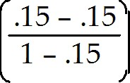 = 0
Diff: 1
Section: 17.4 Dividend Capture and Tax Clienteles
Skill: Analytical
16) The effective dividend tax rate for a pension fund in 2006 is closest to:
A) 20%
B) 0%
C) 25%
D) 15%
Answer: B
Explanation: B) τd = 0%, τg = 0% (pension fund)
= 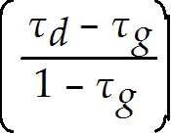 = 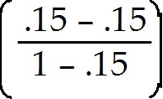 = 0
Diff: 1
Section: 17.4 Dividend Capture and Tax Clienteles
Skill: Analytical

17) The effective dividend tax rate for a buy and hold individual investor in 1999 is closest to:
A) 25%
B) 0%
C) 20%
D) 40%
Answer: D
Explanation: D) τd = 40%, τg = 0% (buy and hold)
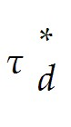= = 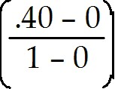 = .40
Diff: 2
Section: 17.4 Dividend Capture and Tax Clienteles
Skill: Analytical

18) The effective dividend tax rate for a one-year individual investor in 1999 is closest to:
A) 0%
B) 20%
C) 25%
D) 40%
Answer: C
Explanation: C) τd = 40%, τg = 20% (one year)
= = 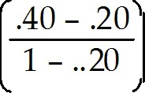 = .25
Diff: 2
Section: 17.4 Dividend Capture and Tax Clienteles
Skill: Analytical
19) The effective dividend tax rate for a pension fund in 1999 is closest to:
A) 40%
B) 20%
C) 0%
D) 25%
Answer: C
Explanation: C) τd = 0%, τg = 0% (pension fund)

= = 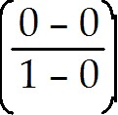 = 0
Diff: 2
Section: 17.4 Dividend Capture and Tax Clienteles
Skill: Analytical

20) Using the available tax information for 2002, calculate the effective dividend tax rate for a:
(1) one-year individual investor
(2) buy and hold individual investor
(3) pension fund
Answer: (1) τd = 39%, τg = 20% (one year)

= = 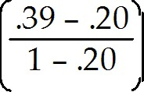 = .2375

(2) τd = 39%, τg = 0% (buy and hold)
= = 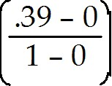 = .39

(3) τd = 0%, τg = 0% (pension fund)
= = = 0
Diff: 2
Section: 17.4 Dividend Capture and Tax Clienteles
Skill: Analytical
17.5 Payout Versus Retention of Cash

Use the following information to answer the question(s) below.

d'Anconia Copper has $200 million in cash that it can use for a share repurchase. Suppose instead that d'Anconia Copper invests the funds in an account paying 5% interest for one year. Assume that the corporate tax rate is 35%, the individual capital gains rate is 15% and the individual rate on ordinary income is 30%.

1) The amount of additional cash that d'Anconia Copper will have at the end of the year net of corporate taxes is closest to:
A) $2.0 million
B) $5.5 million
C) $6.5 million
D) $7.0 million
Answer: C
Explanation: C) Net amount = investment × interest × (1 - tax rate) = $200 million × 5% × (1 - 35%) = 6.5 million
Diff: 1
Section: 17.5 Payout Versus Retention of Cash
Skill: Analytical

2) Net of capital gains taxes, the amount the total value of d'Anconia Copper shares increase is closest to:
A) $5.5 million
B) $6.5 million
C) $7.0 million
D) $10.0 million
Answer: A
Explanation: A) Net amount = investment × interest × (1 - corporate tax rate)(1 - cap gains rate)
= $200 million × 5% × (1 - 35%)(1 - 15%) = 5.525 million
Diff: 1
Section: 17.5 Payout Versus Retention of Cash
Skill: Analytical

3) Net of ordinary income taxes, the amount that investors would have if they invested the $200 million on their own is closest to:
A) $5.5 million
B) $6.5 million
C) $7.0 million
D) $10.0 million
Answer: C
Explanation: C) Net amount = investment × interest × (1 - ordinary tax rate) = $200 million × 5% × (1 - 30%) = $7.0 million
Diff: 1
Section: 17.5 Payout Versus Retention of Cash
Skill: Analytical
4) Suppose that d'Anconia Copper retained the $200 million in cash so that it would not need to raise new funds from outside investors for an expansion it has planned for next year. If it did raise new funds, it would have to pay issuance fees. Assuming that these fees can be expensed for corporate tax purposes, the amount that d'Anconia Copper needs to save in issuance fees to make retaining the cash beneficial for its investors is closest to:
A) $2.0 million
B) $5.5 million
C) $6.5 million
D) $7.0 million
Answer: A
Explanation: A) If the investors had invested the $200 million themselves: Net amount = investment × interest × (1 - ordinary tax rate) = $200 million × 5% × (1 - 30%) = $7.0 million

The amount if the corporation reinvests: Net amount = investment × interest × (1 - corporate tax rate)(1 - cap gains rate) = $200 million × 5% × (1 - 35%)(1 - 15%) = 5.525 million
Total savings then must be equal to 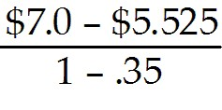 = $2.269 million in fees
Diff: 3
Section: 17.5 Payout Versus Retention of Cash
Skill: Analytical

5) Which of the following statements is FALSE?
A) In perfect capital markets, buying and selling securities is a zero-NPV transaction, so it should not affect firm value.
B) Making positive-NPV investments will create value for the firm's investors, whereas saving the cash or paying it out will not.
C) In perfect capital markets, if a firm invests excess cash flows in financial securities, the firm's choice of payout versus retention is irrelevant and does not affect the initial share price.
D) After adjusting for investor taxes, there remains a substantial tax advantage for the firm to retain excess cash.
Answer: D
Diff: 1
Section: 17.5 Payout Versus Retention of Cash
Skill: Conceptual

6) Which of the following statements is FALSE?
A) A firm must balance the tax costs of holding cash with the potential benefits of having to raise external funds in the future.
B) Paying out excess cash through dividends or share repurchases can boost the stock price by reducing managers' ability and temptation to waste resources.
C) If there is a reasonable likelihood that future earnings will be insufficient to fund future positive-NPV investment opportunities, a firm may start accumulating cash to make up the difference.
D) According to the managerial entrenchment theory of payout policy, managers pay out cash only when pressured to do so by the firm's investors.
Answer: A
Diff: 2
Section: 17.5 Payout Versus Retention of Cash
Skill: Conceptual
7) Which of the following formulas is INCORRECT?
A) τ*retain = 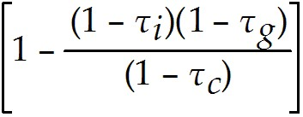
B) Pretain = 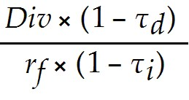
C) Pretain = Pcum × 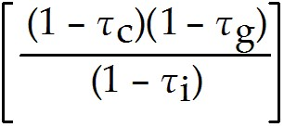
D) Pretain = Pcum × (1 - τ*retain)
Answer: A
Explanation: A) τ*retain = 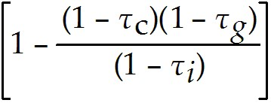
Diff: 2
Section: 17.5 Payout Versus Retention of Cash
Skill: Analytical

8) Consider the following equation:

Pretain = Pcum × 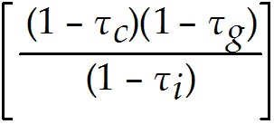

The term τi in this equation represents:
A) the corporation's tax rate on interest income.
B) the investor's tax rate on capital gains.
C) the investor's tax rate on interest income.
D) the investor's tax rate on cumulative dividends.
Answer: C
Diff: 1
Section: 17.5 Payout Versus Retention of Cash
Skill: Analytical

9) Consider the following equation:

Pretain = Pcum ×

The term Pretain in this equation represents:
A) the price of the stock if it retains and invests the cash.
B) the percentage of net income retained or reinvested back into the firm.
C) the percentage of net income paid out as a cash dividend.
D) the price of the stock if it retains cash to use in a share repurchase.
Answer: A
Diff: 1
Section: 17.5 Payout Versus Retention of Cash
Skill: Analytical
10) Consider the following equation:

Pretain = Pcum ×

The term τc in this equation represents:
A) the corporation's tax rate on interest income.
B) the investor's tax rate on interest income.
C) the investor's tax rate on cumulative dividends.
D) the investor's tax rate on capital gains.
Answer: A
Diff: 1
Section: 17.5 Payout Versus Retention of Cash
Skill: Analytical

Use the information for the question(s) below.

Luther Industries has $5 million in excess cash and 1 million shares outstanding. Luther is considering investing the cash in one-year treasury bills that are currently paying 5% interest, and then using the cash to pay a dividend next year. Alternatively, Luther can pay the cash out as a dividend immediately and the shareholders can invest in the treasury bills themselves. Assume that capital markets are perfect.

11) If Luther invests the excess cash in treasury bills, then the dividend per share next year will be closest to:
A) $5.00
B) $5.25
C) $4.75
D) $1.05
Answer: B
Explanation: B) $5M (1.05) = $5,250,000/1,000,000 shares = $5.25
Diff: 1
Section: 17.5 Payout Versus Retention of Cash
Skill: Analytical

12) If Luther decides to pay the dividend immediately the dividend per share will be closest to:
A) $1.05
B) $5.25
C) $5.00
D) $4.75
Answer: C
Explanation: C) $5,000,000 /1,000,000 shares = $5.00
Diff: 1
Section: 17.5 Payout Versus Retention of Cash
Skill: Analytical
13) In 2006, Luther Incorporated paid a special dividend of $5 per share for the 100 million shares outstanding. If Luther has instead retained that cash permanently and invested it into treasury bills earning 5%, then the present value of the additional taxes paid by Luther would be closest to:
A) $35 million
B) $290 million
C) $175 million
D) $585 million
Answer: C
Explanation: C) PV = 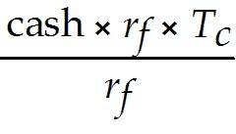 = $5 × 100M shares × .35 = $175 million
Diff: 1
Section: 17.5 Payout Versus Retention of Cash
Skill: Analytical

Use the information for the question(s) below.

Consider the following tax rates:

Year | Corporate Tax Rate | Capital Gains Rate | Ordinary Income Rate | Dividend Rate
1997-2000 | 35% | 20% | 40% | 40%
2001-2002 | 35% | 20% | 39% | 39%
2003- | 35% | 15% | 35% | 15%

14) The effective tax disadvantage for retaining cash in 2006 is closest to:
A) 14.75%
B) 12.50%
C) 35.00%
D) 15.00%
Answer: D
Explanation: D) 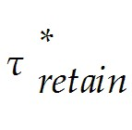 = 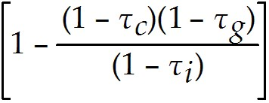 = 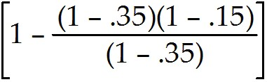 = .15
Diff: 2
Section: 17.5 Payout Versus Retention of Cash
Skill: Analytical

15) The effective tax disadvantage for retaining cash in 2002 is closest to:
A) 15.00%
B) 14.75%
C) 30.00%
D) 35.00%
Answer: B
Explanation: B) = = 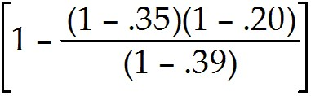 = .1475
Diff: 2
Section: 17.5 Payout Versus Retention of Cash
Skill: Analytical
16) The effective tax disadvantage for retaining cash in 2000 is closest to:
A) 15.00%
B) 13.35%
C) 14.75%
D) 35.00%
Answer: B
Explanation: B) = 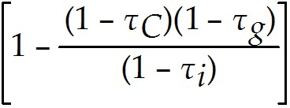 = 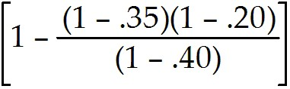 = .13333
Diff: 2
Section: 17.5 Payout Versus Retention of Cash
Skill: Analytical

Use the information for the question(s) below.

Iota Industries is an all-equity firm with 50 million shares outstanding. Iota has $200 million in cash and expects future free cash flows of $75 million per year. Management plans to use the cash to expand the firm's operations, which in turn will increase future free cash flows by 12%. Iota's cost of capital is 10% and assume that capital markets are perfect.

17) The value of Iota if they use the $200 million to expand is closest to:
A) $825 million
B) $688 million
C) $840 million
D) $950 million
Answer: C
Explanation: C) value = 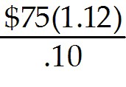 = $840 million
Diff: 2
Section: 17.5 Payout Versus Retention of Cash
Skill: Analytical

18) The value of Iota if they do not use the $200 million to expand and hold the cash instead is closest to:
A) $840 million
B) $825 million
C) $950 million
D) $688 million
Answer: C
Explanation: C) value = 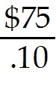 = $750 million + $200 million cash = $950 million
Diff: 2
Section: 17.5 Payout Versus Retention of Cash
Skill: Analytical
19) The price per share of Iota if they use the $200 million to expand is closest to:
A) $13.75
B) $16.50
C) $19.00
D) $16.80
Answer: D
Explanation: D) Value = = $840 million
Price per share = 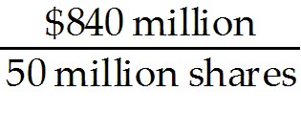 = $16.80
Diff: 2
Section: 17.5 Payout Versus Retention of Cash
Skill: Analytical

20) The price per share of Iota if they decide not to use the $200 million to expand and hold the cash instead is closest to:
A) $16.50
B) $16.80
C) $19.00
D) $13.75
Answer: C
Explanation: C) Value = = $750 million + $200 million cash = $950 million
Price per share = 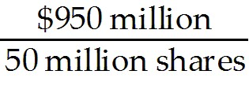 = $19.00
Diff: 2
Section: 17.5 Payout Versus Retention of Cash
Skill: Analytical

21) The NPV of Iota's expansion project is closest to:
A) -$110 million
B) -$137.5 million
C) $0
D) $75 million
Answer: A
Explanation: A) NPV = -200 + 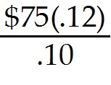 = -$110 million
Diff: 2
Section: 17.5 Payout Versus Retention of Cash
Skill: Analytical
22) A member of Iota's board of directors suggests that Iota's stock price would be higher if they used the $200 million to repurchase shares instead of funding the expansion. If you were advising the board, what course of action would you recommend, expansion or repurchase? Which provides the higher stock price?
Answer: Value with expansion:
Value = = $840 million
Price per share = = $16.80

Value with repurchase (since capital markets are perfect we know that the stock price with the repurchase will be identical to the stock price before the repurchase takes place):
Value = = $750 million + $200 million cash = $950 million
Price per share = = $19.00

The other way to show that the expansion is a bad idea is to calculate the NPV of the project:
NPV = -200 + = -$110 million
So, you should recommend that they use the cash for a share repurchase.
Diff: 3
Section: 17.5 Payout Versus Retention of Cash
Skill: Analytical
23) Suppose that Iota is able to invest the $200 million in excess cash into a project that will increase future free cash flows by 30%. If you were advising the board, what course of action would you recommend, investing the $200 million in an expansion project that will raise future free cash flows by 30% or use the $200 million to repurchase shares? Which provides the higher stock price?
Answer: Value with expansion:
Value = 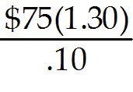 = $975 million
Price per share = 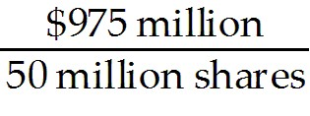 = $19.50

Value with repurchase (since capital markets are perfect we know that the stock price with the repurchase will be identical to the stock price before the repurchase takes place):
Value = = $750 million + $200 million cash = $950 million
Price per share = = $19.00

The other way to show that the expansion is a good idea is to calculate the NPV of the project:
NPV = -200 + 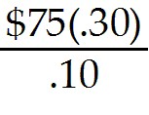 = $25 million
So, you should recommend that they invest in the expansion project that offers the 30% increase in FCF.
Diff: 2
Section: 17.5 Payout Versus Retention of Cash
Skill: Analytical
Use the information for the question(s) below.

Consider the following tax rates:

Year | Corporate Tax Rate | Capital Gains Rate | Ordinary Income Rate | Dividend Rate
1997-2000 | 35% | 20% | 40% | 40%
2001-2002 | 35% | 20% | 39% | 39%
2003- | 35% | 15% | 35% | 15%

24) Calculate the effective tax disadvantage for retaining cash in 1999, 2001, and 2005.
Answer: 1999: = = = .13333

2001: = = = .1475

2005: = = = .15
Diff: 2
Section: 17.5 Payout Versus Retention of Cash
Skill: Analytical

17.6 Signaling with Payout Policy

1) Which of the following statements is FALSE?
A) Firms adjust dividends relatively infrequently, and dividends are much less volatile than earnings. This practice of maintaining relatively constant dividends is called dividend signaling.
B) When a firm increases its dividend, it sends a positive signal to investors that management expects to be able to afford the higher dividend for the foreseeable future.
C) The average size of the stock price reaction increases with the magnitude of the dividend change, and is larger for dividend cuts.
D) When managers cut the dividend, it may signal that they have given up hope that earnings will rebound in the near term and need to reduce the dividend to save cash.
Answer: A
Diff: 2
Section: 17.6 Signaling with Payout Policy
Skill: Conceptual
2) Which of the following statements is FALSE?
A) If firms smooth dividends, the firm's dividend choice will contain information regarding management's expectations of future earnings.
B) Because of the increasing popularity of repurchases, firms cut dividends much more frequently than they increase them.
C) Announcing a share repurchase today does not necessarily represent a long-term commitment to repurchase shares.
D) While cutting the dividend is costly for managers in terms of their reputation and the reaction of investors, it is by no means as costly as failing to make debt payments.
Answer: B
Diff: 2
Section: 17.6 Signaling with Payout Policy
Skill: Conceptual

3) Which of the following statements is FALSE?
A) Managers are much less committed to dividend payments than to share repurchases.
B) Share repurchases are a credible signal that the shares are under-priced, because if they are over-priced a share repurchase is costly for current shareholders.
C) While an increase of a firm's dividend may signal management's optimism regarding its future cash flows, it might also signal a lack of investment opportunities.
D) Managers will clearly be more likely to repurchase shares if they believe the stock to be under-valued.
Answer: A
Diff: 2
Section: 17.6 Signaling with Payout Policy
Skill: Conceptual

Use the information for the question(s) below.

Rockwood Industries has 100 million shares outstanding, a current share price of $25, and no debt. Rockwood's management believes that the shares are under-priced, and that the true value is $30 per share. Rockwood plans to pay $250 million in cash to its shareholders by repurchasing shares. Management expects that very soon new information will come out that will cause investors to revise their opinion of the firm and agree with Rockwood's assessment of the firm's true value.

4) If Rockwood is able to repurchase shares prior to the market becoming aware of the new information regarding Rockwood's true value, then the number of shares outstanding following the repurchase is closest to:
A) 92 million
B) 10 million
C) 75 million
D) 90 million
Answer: D
Explanation: D) Number of shares repurchased = 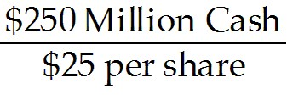 = 10 million shares
So, total shares outstanding after repurchase = 100 million initial - 10 million repurchased = 90 million remaining.
Diff: 1
Section: 17.6 Signaling with Payout Policy
Skill: Analytical
5) Assume that Rockwood is not able to repurchase shares prior to the market becoming aware of the new information regarding Rockwood's true value. If Rockwood repurchases the shares following the release of the new information, then the number of shares outstanding following the repurchase is closest to:
A) 92 million
B) 90 million
C) 75 million
D) 10 million
Answer: A
Explanation: A) Number of shares repurchased = 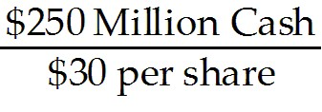 = 8,333,333 shares
So, total shares outstanding after repurchase = 100,000,000 million initial - 8,333,333 repurchased = 91,666,667 total shares outstanding
Diff: 1
Section: 17.6 Signaling with Payout Policy
Skill: Analytical

6) Assume that Rockwood is able to repurchase shares prior to the market becoming aware of the new information regarding Rockwood's true value. After the repurchase, and following the release of the new information regarding the true value of Rockwood, the firm's share price is closest to:
A) $30.00
B) $31.50
C) $28.75
D) $30.60
Answer: D
Explanation: D) Number of shares repurchased = = 10 million shares
So, total shares outstanding after repurchase = 100 million initial - 10 million repurchased = 90 million remaining.

True value of the firm before repurchase = $30 × 100 million shares = 3000 million.
True value after repurchase = $3000 million - $250 million in cash spent on repurchase = $2750 million
Price per share = 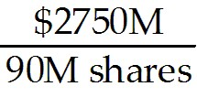 = $30.56
Diff: 2
Section: 17.6 Signaling with Payout Policy
Skill: Analytical
7) Assume that Rockwood is not able to repurchase shares prior to the market becoming aware of the new information regarding Rockwood's true value. After the release of the new information regarding the true value of Rockwood, and following the repurchase, the firm's share price is closest to:
A) $30.00
B) $30.60
C) $28.75
D) $31.50
Answer: A
Explanation: A) Number of shares repurchased = = 8,333,333 shares
So, total shares outstanding after repurchase = 100,000,000 million initial - 8,333,333 repurchased = 91,666,667 total shares outstanding

True value of the firm before repurchase = $30 × 100 million shares = 3000 million.
True value after repurchase = $3000 million - $250 million in cash spent on repurchase = $2750 million
Price per share = 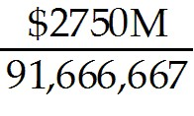 = $30.00
Diff: 2
Section: 17.6 Signaling with Payout Policy
Skill: Analytical
8) Calculate Rockwood's stock price following the market becoming aware of the new information regarding Rockwood's true value, if (1) Rockwood completed the repurchase prior to the market becoming aware of the information and (2) Rockwood completed the repurchase following the market becoming aware of the new information.
Answer: (1) Rockwood completed the repurchase prior to the market becoming aware of the information
Number of shares repurchased = = 10 million shares
So, total shares outstanding after repurchase = 100 million initial - 10 million repurchased = 90 million remaining.

True value of the firm before repurchase = $30 × 100 million shares = 3000 million.
True value after repurchase = $3000 million - $250 million in cash spent on repurchase = $2750 million
Price per share = = $30.56

(2) Rockwood completed the repurchase following the market becoming aware of the new information
Number of shares repurchased = = 8,333,333 shares
So, total shares outstanding after repurchase = 100,000,000 million initial - 8,333,333 repurchased = 91,666,667 total shares outstanding

True value of the firm before repurchase = $30 × 100 million shares = 3000 million.
True value after repurchase = $3000 million - $250 million in cash spent on repurchase = $2750 million
Price per share = = $30.00
Diff: 3
Section: 17.6 Signaling with Payout Policy
Skill: Analytical

17.7 Stock Dividends, Splits, and Spin-offs

1) Taggart Transcontinental shares are currently trading at $200 per share. The split ratio needed to bring the stock price down to $80 is:
A) 2:1
B) 3:1
C) 2:5
D) 5:2
Answer: D
Explanation: D) The ratio needed is $200/$80 = 20/8 = 10/4 = 5/2 or 5:2 in simplest form.
Diff: 1
Section: 17.7 Stock Dividends, Splits, and Spin-offs
Skill: Analytical
2) Which of the following statements is FALSE?
A) Stocks generally trade in lots of 1000 shares, and in any case do not trade in units less than one share.
B) Non-cash special dividends are commonly used to spin off assets or a subsidiary as a separate company.
C) The typical motivation for a stock split is to keep the share price in a range thought to be attractive to small investors.
D) If a company declares a 10% stock dividend, each shareholder will receive one new share of stock for every 10 shares already owned.
Answer: A
Diff: 1
Section: 17.7 Stock Dividends, Splits, and Spin-offs
Skill: Conceptual

3) Which of the following statements is FALSE?
A) With a stock dividend, a firm does not pay out any cash to shareholders. As a result, the total market value of the firm's assets and liabilities, and therefore of its equity, is unchanged.
B) If the price of the stock falls too low, a company can engage in a reverse split and reduce the number of shares outstanding.
C) Stock dividends of 50% or higher are generally referred to as stock splits.
D) Rather than pay a dividend using cash or shares of its own stock, a firm can also distribute shares of a subsidiary in a transaction referred to as a off-shoot.
Answer: D
Diff: 1
Section: 17.7 Stock Dividends, Splits, and Spin-offs
Skill: Conceptual

Use the information for the question(s) below.

Luther Industries currently has 5 million shares outstanding and its stock is currently trading at $40 per share.

4) Assuming Luther issues a 25% stock dividend, then Luther's new share price is closest to:
A) $24.00
B) $30.00
C) $16.00
D) $32.00
Answer: D
Explanation: D) New share price = 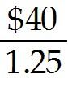 = $32
Diff: 1
Section: 17.7 Stock Dividends, Splits, and Spin-offs
Skill: Analytical
5) Assuming Luther issues a 5:2 stock split, then Luther's new share price is closest to:
A) $32.00
B) $16.00
C) $24.00
D) $30.00
Answer: B
Explanation: B) New share price = 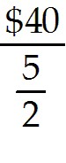 = $16
Diff: 2
Section: 17.7 Stock Dividends, Splits, and Spin-offs
Skill: Analytical

6) Assuming Luther issues a 5:2 stock split, then the number of shares Luther will have outstanding following the split is closest to:
A) 25.0 million
B) 12.5 million
C) 2.0 million
D) 16.0 million
Answer: B
Explanation: B) shares outstanding following split = current shares outstanding × split
= 5 million × 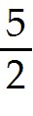 = 12.5 million
Diff: 1
Section: 17.7 Stock Dividends, Splits, and Spin-offs
Skill: Analytical

7) Delta Products has decided to spin-off one of its subsidiaries, Gamma Technologies. Each Delta shareholder will receive 0.125 shares of Gamma for each share of Delta they own. Delta's price is $35.00 cum-dividend and immediately after the spin-off Gamma Technologies was trading for $24.00 per share. In a perfect capital market, what would Delta Product's ex-dividend share price be after this transaction?
Answer: The value of the special dividend is:
0.125 Gamma shares × $24.00 per share = $3.00
So we expect Delta's stock price to drop by $3.00 per share. So final stock price = $35.00 - $3.00 = $32.00
Diff: 2
Section: 17.7 Stock Dividends, Splits, and Spin-offs
Skill: Analytical

